Problem Statement:

Recently, ChatGPT has been one of the most discussed topics. Twitter is a popular social media platform for people to connect and share their thoughts. Analyzing Twitter data provides deep insights into the way people think. By analyzing Twitter data on ChatGPT we can obtain valuable information. Hence, there is a need for a ChatGPT tweet analyzer application. A relational database provides many advantages like access, security, and integrity of the data compared to other earlier storage systems like files. Many users can concurrently access the database, the data is secured as access is required for data access. Any RDBMS promises data integrity with its ACID properties.

Functional Requirements:

Functional Requirements of our application from the given dataset:

1. Most active users from the dataset.
2. Most liked Tweet about ChatGPT.
3. Most used media in the Tweet.
4. Number of Hashtags used by user in the tweet.
5. Most discussed tweet with respect to replies on conversation ID
6. Most used language to express about ChatGPT.
7. Most retweeted tweet in each language.
8. Top Ten users who have more outlinks.
9. Conversations with most number of media shares.
10. Number of Tweets on each day on ChatGPT.
11. Get the most viral tweet with respect to retweet, quotes, likes.
12. Most used hashtag counts.
13. Most used source for tweeting.
14. Most mentioned user in the tweets.
15. Automated update of hashtag table after insertion to the tweet table.
16. Uniform tweet length maintenance restriction.
17. Auditing any deleted tweets .

**SPECIFICATIONS:**

My SQL Workbench 8.0.30

MySQL Libraries

Python Libraries: Pymysql, Sqlalchemy

AWS-RDS DB Instance

SJSU ChatGPT Analyzer application has a two-tier architecture. The Analyzer app acts as a client to the AWS RDS MySQL Instance which acts as a server. AWS RDS provides a cloud-based database environment that caters to the data need of our application. The raw data which is in the form of a .csv file is extracted using a python program and then cleaned and transformed into the required format and then loaded into the ‘twitter’ database in AWS RDS MySQL Instance. The application runs on a command line interface and the user of our application can select options to view a few of the interesting metrics that can be obtained from the application. The developer can connect to AWS RDS MySQL Instance endpoints either through a MySQL client or through the python application.

ER DIAGRAM

**TABLE STRUCTURE**

**/*------- CREATING DATABASE -----------*/**

create database twitter;

use twitter;

**/*------- CREATING TABLES ----*/**

**/* Users Table */**

create table users (

username varchar(50) not null primary key,

User_url varchar (50),

user_info varchar(1000)

);

**/* Media table */**

create table media(

media_id bigint not null primary key,

media_details text not null,

media_type varchar(10)

);

**/* Tweet Table */**

create table tweets

(

Tweetid bigint not null primary key,

username varchar(20) not null,

tweettext text not null,

createdtime datetime not null,

lang varchar(10) not null,

conversation_id bigint not null,

media_id bigint default null,

foreign key (username) references users(username) on delete cascade,

foreign key (media_id) references media(media_id)

);

**/* Public Metrics Table */**

create table public_metrics (

tweetid bigint not null primary key,

reply_count int not null default 0,

retweet_count int not null default 0,

like_count int not null default 0,

quote_count int not null default 0,

foreign key (tweetid) references tweets(tweetid) on delete cascade

);

**/* Hash tag Table */**

create table hash_tags

(

tweetid bigint not null,

hash_tag varchar(1000) not null,

hastag_count int,

foreign key (tweetid) references tweets(tweetid) on delete cascade

);

**/* Url Table */**

create table tweet_links

(

tweetid bigint not null,

permalink_url varchar(100) not null,

source_url varchar(200) not null,

count_link text not null,

out_link text not null,

foreign key (tweetid) references tweets(tweetid) on delete cascade

);

**/* Quoted Tweet table */**

create table quoted_tweets(

tweetid bigint not null,

quoted_tweet varchar(100) not null,

**foreign key** (tweetid) references tweets(tweetid) on delete cascade

);

**/* User Mentions Table */**

create table user_mentions (

tweetid bigint not null,

username text not null,

**foreign key** (tweetid) references tweets(tweetid) on delete cascade

);

**Usage of triggers and Procedures:**

**Trigger:**

A Database trigger is automated execution of the procedural code in response to an event on a particular table or view in database.Triggers are mainly used for maintaining the integrity of the information for a database. For example, whenever the new record(from existing user) is inserted into the tweet table the trigger should automatically fire and the hash tag table should get updated and triggers can also be used for auditing.

**Stored Procedure**

A stored procedure is similar to a function in python or C.It is a subroutine used to access a RDS.

These stored procedure is sequence of SQL statements whichis stored in server and used whenever required by, calling the procedures.

**RESULTS**

1..

**Query:**

/* Active Users tweeted in given time in descending order */

SELECT username as active_users,COUNT(tweetid) as tweet_count

FROM tweets

GROUP BY username

ORDER BY COUNT(tweetid) DESC limit 10;

2.

Query:

/* Most Liked Tweet about ChatGPT */

select tweetid,username,tweettext,createdtime,like_count from tweets join public_metrics using (tweetid)

order by like_count desc;

3.

**Query**

/* Most Used Media Type */

select media_type, count(*)as media_used from media

group by media_type

order by media_used desc;

4

**Query**

/*User who have used more Hashtags */

select username,tweetid,hash_tag,hastag_count from tweets join hash_tags using (tweetid) order by hastag_count desc;

5.

**Query**

/* Most Discussed tweet with respect to replies based on conversation id in the given data */

SELECT tweetid,username,conversation_id,COUNT(*) as reply_to_tweet

FROM tweets

GROUP BY conversation_id

ORDER BY reply_to_tweet DESC limit 15;

6.

Query

/* Most used Language to express about ChatGPT */

7.

-- Most retweeted tweet in each language

with langquery as (

select tweetid, `lang`, username, tweettext, retweet_count,

row_number() over (partition by `lang` order by retweet_count desc) as rownum

from tweets join public_metrics using (tweetid))

Select * from langquery

where rownum =1

8.

-- top 10 Users who have more outlinks

select username, count(out_link) as `Number of links`

from tweets join tweet_links using (tweetid)

group by username

order by count(out_link) desc

limit 10;

9.

-- conversations with most number of media shares

select conversation_id, media_type, count(media_id) as `number of media shared`

from tweets join media using (media_id)

group by conversation_id, media_type

order by count(media_id) desc

limit 10;

10.

-- Number of tweets each day on chatGPT

select date(createdtime) as Tweeted_date, count(tweetid) as tweet_count

from tweets

group by Tweeted_date;

**Stored_procedure**

1.viral tweet

**Query**

DROP PROCEDURE get_most_viral_tweet;

DELIMITER //

CREATE PROCEDURE get_most_viral_tweet()

BEGIN

SELECT t.username,t.tweetid,t.tweettext, t.createdtime,

COALESCE(pm.retweet_count, 0) + COALESCE(pm.quote_count, 0)+COALESCE(pm.like_count, 0) AS total_count

FROM tweets t

LEFT JOIN public_metrics pm ON t.tweetid = pm.tweetid

ORDER BY total_count DESC

LIMIT 15;

END; //

CALL get_most_viral_tweet();

2.most used hashtag

Query

/*-----------Most used Hashtags------------*/

DROP PROCEDURE IF EXISTS GET_HASHTAG_COUNT;

DELIMITER //

CREATE PROCEDURE GET_HASHTAG_COUNT()

BEGIN

DECLARE val TEXT DEFAULT NULL;

DECLARE firstVal TEXT DEFAULT NULL;

DECLARE firstValLen INT DEFAULT NULL;

DECLARE tempVal TEXT DEFAULT NULL;

DECLARE finished INT DEFAULT 0;

DECLARE CUR CURSOR FOR SELECT HASH_TAG FROM hash_tags;

DECLARE CONTINUE HANDLER FOR NOT FOUND SET finished = 1;

DROP TABLE IF EXISTS HASHTAG_SPLIT_TABLE;

CREATE TABLE HASHTAG_SPLIT_TABLE(HASHTAG TEXT);

OPEN CUR;

get_hashtag: LOOP

FETCH CUR INTO val;

IF finished = 1 THEN

LEAVE get_hashtag;

END IF;

iterator: LOOP

IF LENGTH(val) = 0 OR val IN ('[]') OR val IS NULL THEN

LEAVE iterator;

END IF;

IF val NOT LIKE '[%]' THEN

SET val = trim(trailing '\"' from trim(leading '\"' from val));

END IF;

IF val LIKE '[%]' THEN

SET val = trim(trailing ']' from trim(leading '[' from val));

END IF;

SET firstVal = SUBSTRING_INDEX(VAL,',',1);

SET firstValLen = LENGTH(firstVal);

SET tempVal = trim(trailing '\'' from trim(leading '\'' from TRIM(firstVal)));

SET tempVal = trim(trailing '\'' from trim(leading '\'' from TRIM(tempVal)));

IF LENGTH(tempVal) = 0 OR tempVal IS NULL THEN

LEAVE iterator;

END IF;

INSERT INTO HASHTAG_SPLIT_TABLE (HASHTAG) VALUES (tempVal);

SET val = INSERT(val,1,firstValLen + 1,'');

END LOOP;

END LOOP;

CLOSE CUR;

SELECT HASHTAG, COUNT(HASHTAG)as used_count FROM HASHTAG_SPLIT_TABLE GROUP BY HASHTAG ORDER BY COUNT(HASHTAG) DESC LIMIT 10;

END //

DELIMITER ;

CALL GET_HASHTAG_COUNT();

3.

Query

/*------------- Most used Source -----*/

drop procedure if exists most_used_source;

DELIMITER //

CREATE PROCEDURE most_used_source()

BEGIN

SELECT SUBSTRING_INDEX(SUBSTRING_INDEX(source_url, '>', -2), '<', 1) AS used_source,

COUNT(*) AS most_used_source

FROM tweet_links

WHERE

source_url LIKE '%twitter.com%'

GROUP BY used_source

ORDER BY most_used_source DESC

LIMIT 10;

end //

call most_used_source()

4.

Query

/* Most Mentioned Use */

drop procedure if exists most_mentioned_user ;

DELIMITER //

CREATE PROCEDURE most_mentioned_user()

BEGIN

SELECT mentioned_user, COUNT(*) AS mention_count

FROM (SELECT regexp_SUBSTR(tweettext, '@[[:alnum:]_]+') AS mentioned_user

FROM tweets) AS t

WHERE mentioned_user != ''

GROUP BY mentioned_user

ORDER BY mention_count DESC limit 20;

end //

call most_mentioned_user()

**Triggers**

1.most viral tweet

Pending

**1**

**2.**

**Query**

/*-------Trigger to not update if tweet text length is > 280.......*/

drop trigger if exists trigger_tweet_length;

DELIMITER //

CREATE TRIGGER trigger_tweet_length

BEFORE insert ON tweets

FOR EACH ROW

BEGIN

IF LENGTH(NEW.tweettext) > 280 THEN

SIGNAL SQLSTATE '45000'

SET MESSAGE_TEXT = 'Tweet text cannot be longer than 280 characters';

END IF;

END;//

insert into tweets (tweetid,tweettext) values (161050057205020000,'aaaaaaaaaaaaaaaaaaaaaaaaa

aaaaaajjjjjjjjjjjjjjjjjjjjjjjjjjjjjjjjjjaaaaaaaaaaaaaaaaaaaaaaaaaaaaaaa

jjjjjjjjjjjjjjjjjjjjjjjjjjjjjjjjjjaaaaaaaaaaaaaaaaaaaaaaaaaaaaaaajjjjjjjj

jjjjjjjjjjjjjjjjjjjjjjjjjjaaaaaaaaaaaaaaaaaaaaaaaaaaaaaaajjjjjjjjjjjjjjjj

jjjjjjjjjjjjjjjjjjaaaaaaaaaaaaaaaaaaaaaaaaaaaaaaajjjjjjjjjjjjjjjjjjjjjjjjjjjjjjjjjjaaaaaaaaaa

aaaaaaaaaaaaaaaaaaaaajjjjjjjjjjjjjjjjjjjjjjjjjjjjjjjjjj');

**3.**

CREATE TABLE log (

delete_timestamp datetime primary key,

db_user varchar(50),

tweet_id bigint not null,

username varchar(50) not null

);

DELIMITER //

CREATE TRIGGER log_before_delete

Before delete ON tweets

FOR EACH ROW

BEGIN

INSERT INTO log values (now(),user(),old.tweetid,old.username);

END;//

delete from tweets where username='priyanka';

Log Table Before data was Deleted

Log Table After data was Deleted

**USER INTERFACE**

User can select pre defined sql queries to obtain the required results in the application.

**User Interface**

**Query giving most used hashtags in user interface**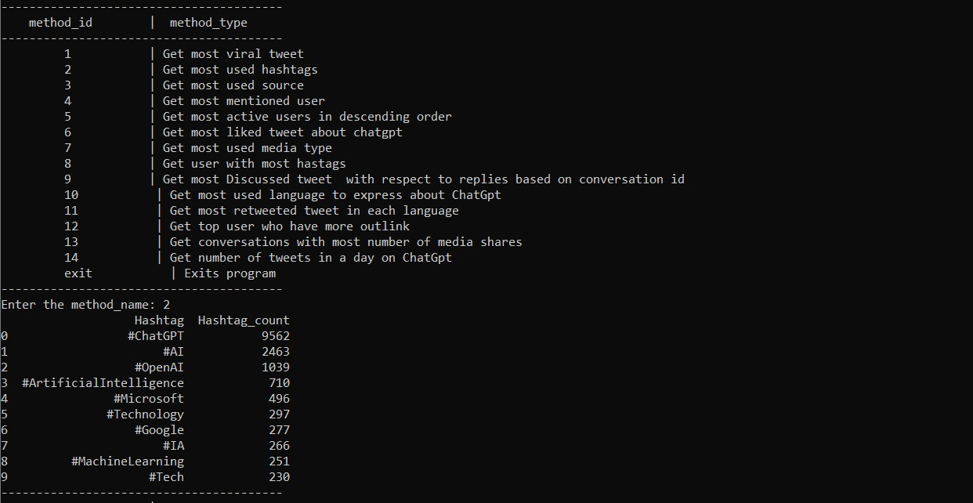

**Most used source result in user interface**

